6A^{th} Grade: Unit 10, Lesson 7

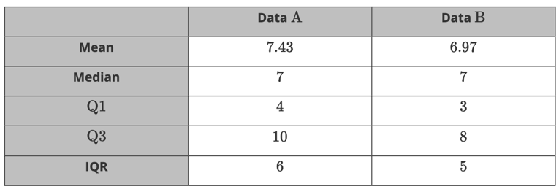
- The summary of two sets of data is shown. Which dataset has the larger interquartile range?

Dataset A has a larger IQR

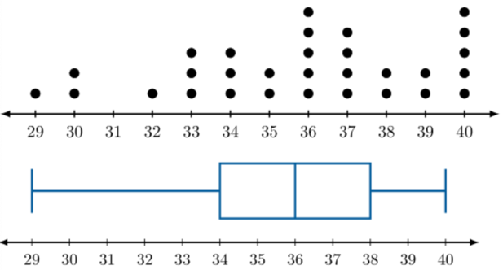

- A science club created the data displays shown from the same set of data. Which graph would you use to determine how many pieces of data were collected?

The line plot

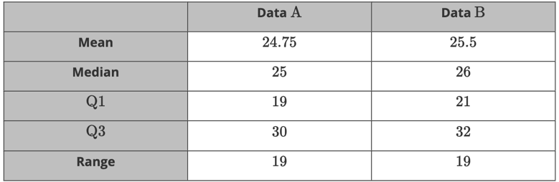
- Which data set has the larger median?

Dataset B

